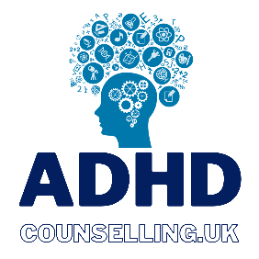

ADHD COUNSELLING UK COUNSELLING DIRECTORY SIGN-UP FORM
Please complete the form with as much information as you would like featured.
Once completed, please send with a headshot photo and link to proof of professional body registration to contact@adhdcounselling.uk

Name

Email
Telephone Number
Governing Body Membership (ie BACP, UKCP, NCS, or international equivalent)

Approximate location (if working in-person)

Do you offer online, telephone, chat or text services? | Online ☐  Telephone ☐  Chat ☐  Text ☐  Facetime ☐  Other (please specify)
How would you like to be contacted? | Email ☐  Text ☐  Call ☐  WhatsApp ☐
Website

Social Media Links | Facebook:  LinkedIn:  Instagram:  Twitter:  TikTok:  Snapchat:  Twitch:  Other:
Fee
Introduction Text – a bio about you. Please include any specialisations you’d like featured.
Your ADHD credentials.

Not for publication – please talk a little about your personal or professional experience working with ADHD.

All information is held in accordance with GDPR laws and directives, as per conditions of the ICO register. (Membership number ZB319196)
Please note: registration for ADHD Counselling UK is free until 31/03/2023 and thereafter a monthly fee of £12.99 is chargeable. Full details will be sent to listed counsellors 01/02/2023.

